ITSimplera Institute

WEAK NO 1 TASK

Submitted By:-

💐 MUHAMMAD ISMAIL 💐

Introduction:-
Computer networking is the process of connecting two or more computers or devices so they can communicate and share data. Networks are used in homes, schools, offices, and organizations to exchange information and access shared resources such as printers, files, and the Internet.
In this lab, we learned the basic concepts of computer networking and explored two popular network simulation tools: Cisco Packet Tracer and GNS3. These tools allow users to design, configure, and test computer networks without using physical networking equipment.
The main objective of this lab was to understand networking fundamentals, build a simple Local Area Network (LAN), configure static IP addresses, and verify communication between devices using the ping command. This practical activity helped us improve our networking knowledge and become familiar with industry-standard network simulation software.
Objectives:-
The objectives of this lab were:
- To understand the basic concepts of computer networking.
- To learn the functions of common networking devices.
- To install and explore Cisco Packet Tracer and GNS3.
- To create a simple LAN topology.
- To configure static IP addresses on end devices.
- To test communication using the ping command.
- To understand the basic interface of Cisco Packet Tracer and GNS3.
- To improve practical networking and troubleshooting skills.
Networking Concepts Learned:-
During this lab, we learned several basic networking concepts.
Local Area Network (LAN):-
A LAN is a network that connects computers within a small area such as a home, office, school, or laboratory.
IP Address:-
An IP address is a unique number assigned to every device connected to a network. It allows devices to communicate with each other.
Example:
- PC1: 192.168.1.1
- PC2: 192.168.1.2
Switch:-
A switch is a networking device that connects multiple computers within the same LAN and forwards data to the correct destination.
Router:-
A router connects different networks together and allows communication between them.
Static IP Address:-
A static IP address is manually assigned to a device and remains the same until it is changed by the user.
Ping Command:-
The ping command is used to test whether two devices can communicate over a network. If the ping is successful, it means the network is working correctly.

Cisco Packet Tracer Interface Overview:-
Cisco Packet Tracer is a network simulation software developed by Cisco. It is widely used by students and beginners to learn networking concepts and practice Cisco device configuration.
The main parts of Cisco Packet Tracer include:
- Menu Bar
- Toolbar
- Workspace
- Device Selection Panel
- Connection Tools
- Realtime Mode
- Simulation Mode
During this lab, we used Cisco Packet Tracer to create a simple LAN consisting of one switch and two PCs. After assigning IP addresses, we verified communication using the ping command.
GNS3 Interface Overview:-
GNS3 (Graphical Network Simulator-3) is an advanced network simulation platform that allows users to run real Cisco operating systems. It is commonly used by network engineers for learning, testing, and certification preparation.
The main parts of GNS3 include:
- Menu Bar
- Toolbar
- Devices Panel
- Workspace
- Console Window
- Server Status
Unlike Cisco Packet Tracer, GNS3 provides a more realistic networking environment because it supports real router images and command-line configuration.
For this lab, we created a simple LAN using an Ethernet Switch and two Virtual PCs (VPCS).
Practical Work Performed:-
Part A – Cisco Packet Tracer
The following tasks were completed:
- Opened Cisco Packet Tracer.
- Added one Cisco 2960 switch.
- Added two PCs.
- Connected both PCs to the switch using Copper Straight-Through cables.
- Configured the IP address of PC0 as 192.168.1.1.
- Configured the IP address of PC1 as 192.168.1.2.
- Configured the IP address of PC2 as 192.168.1.3.
- Assigned the subnet mask 255.255.255.0 to all PCs.
- Opened the Command Prompt on PC1.
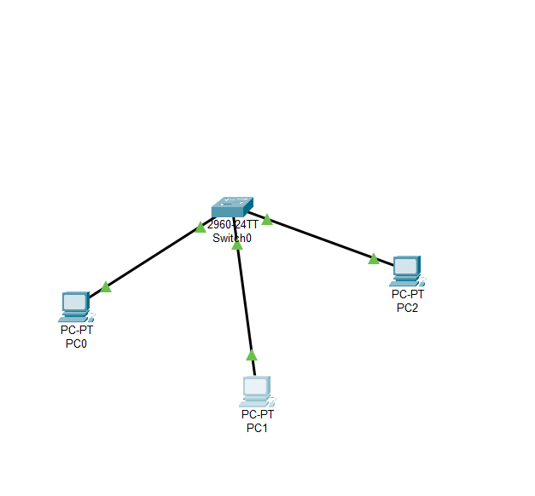

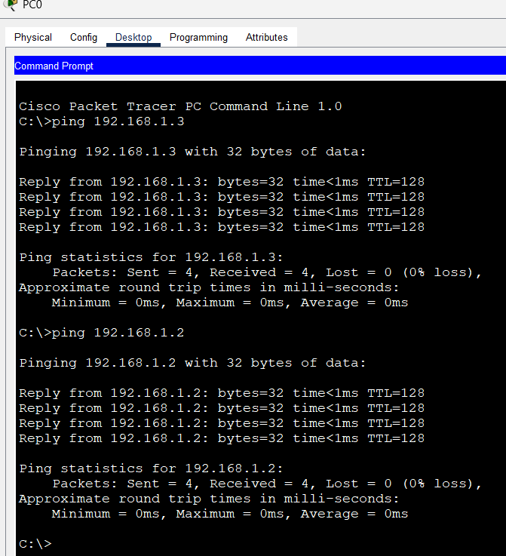
Part B – GNS3
The following tasks were completed:
- Installed and opened GNS3.
- Created a new project .
- Added one Ethernet Switch.
- Added two Virtual PCs (VPCS).
- Connected both VPCS devices to the switch.
- Started all devices.
- Opened the console of VPCS1 and configured the IP address:
ip 192.168.1.1/24
- Opened the console of VPCS2 and configured the IP address:
ip 192.168.1.2/24
- Tested connectivity using:
ping 192.168.1.2
- The ping test was successful, confirming that the network was functioning correctly.

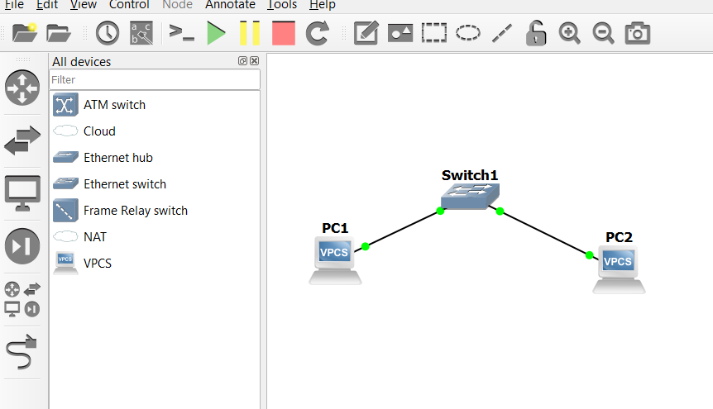

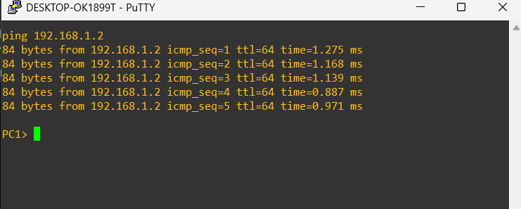

Results:-
The practical work was completed successfully in both Cisco Packet Tracer and GNS3.
The following results were observed:
- Both devices received correct IP addresses.
- The switch connected both end devices successfully.
- The ping command returned successful replies.
- Network connectivity was verified in both simulation tools.
- Basic LAN communication was established successfully.
Conclusion:-
This lab provided practical knowledge of basic computer networking and network simulation tools. We successfully learned how to create a simple Local Area Network (LAN), assign static IP addresses, and test communication between devices using the ping command. We also became familiar with the interfaces of Cisco Packet Tracer and GNS3.
Overall, the lab improved our understanding of networking fundamentals and gave us hands-on experience with two important network simulation platforms used by students and network professionals.

